The Indian Institute of Metals
Cordially
Invites you at the First AMIIM Alumni Meet scheduled to be held with the Commencement Ceremony on Friday , 21st July 2017 preceding the Annual General Meeting 2017 .

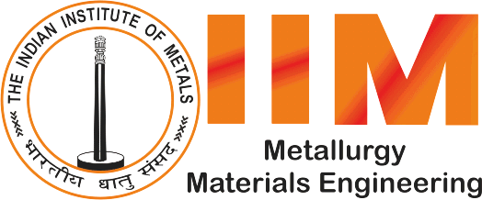
AMIIM ALUMNUS
REUNION

For inquiries,contact Ms.Atashi Saha at 9051648575/atashi.sahaiiom@gmail.com

Venue : Eco Vista Club,
Eco Space Business Park Premises,
CBD,Rajarhat,Kolkata 156
Time : 3Pm onwards

